# **Course: Object-Oriented Programming**

# **Lab 08**

**Inheritance**

**Task 1:**

Make a class **Address** which has two private attribute city and country and one fully parametrized constructor.

Make a class **Person** that has two private attribute name and address. Attribute address should be of type Address. This class has fully parameterized constructor.

Make another class **Student**. Class Student is inherited from class Person. This class has three private attributes program, year and fee and one fully parametrized constructor.

Make a class **Staff** that is inherited from class Person. This class has one attribute that is pay and has one fully parameterized constructor.

In test class, create one object for Student and one for Staff. Ask user to input all information of Student and Staff and print values of all attributes.

All attributes are private.

**Expected Output:**

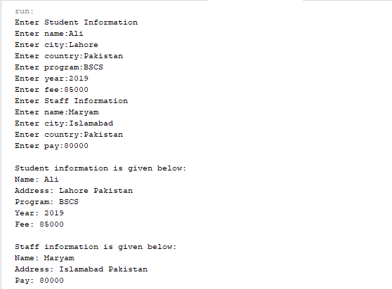

**Task 2:**

Make a class **Circle** that has two private attribute **color** and **radius**. Create a fully parameterized constructor. This class has a method ***calculateArea(),*** which calculates area of circle. This class is inherited by **Cylinder** that has one private attribute height. Create a fully parameterized constructor. This class overrides ***calculateArea() method.***

In test class, call calculateArea() method of Cylinder. Put all classes in com.oop.lab.inheritance package.

Area of Cylinder= 2(πr² + πrh)

Hint: πr²= Area of Circle

**Expected Output:**



**Task 3:**

Make a class **Shape** that has one private attribute color. Create a fully paramterized constructor. This class has two public method ***calculteArae()*** and ***calculatePerimeter().*** Both methods return 0.

Make a class **Circle** that has one private attribute radius. Class Circle is inherited from class Shape. Create a fully parameterized constructor.

Make a class **Rectangle** that extends Shape, and it has two private attribute width and length. Create a fully parametrized constructor.

All sub classes overrides the ***calculteArae()*** and ***calculatePerimeter().***

**Declare the method of Shape class “calculateArea()” as final. Check the error. Declare the Shape class as final. Check the error.**

In test class create ask user to input all values and display area and perimeter for Circle and Rectangle.

Put all classes in com.oop.lab.overriding package.

**Expected Output:**

